# **MIAQuant_LearnTMA: User manual**

* Rinomina l’immagine secondo il formato richiesto:

LIPOMIX-MB-TMA1-Red50_CD163_MLight-M.tif

* Estrarre da QuPath I TMA DATA (Extract->TMA DATA): QuPath Produce una dir che contiene le sottoimmagini e un file con estensione .qptdata (qualcosa del genere). Rinomina la cartella creata e dalle lo stesso nome dell’imagine e rinomina il file con il nome della immagine e modifica la estensione con .txt

Fai questo per tutte le immagini da processare e avrai una cartella come segue:

* 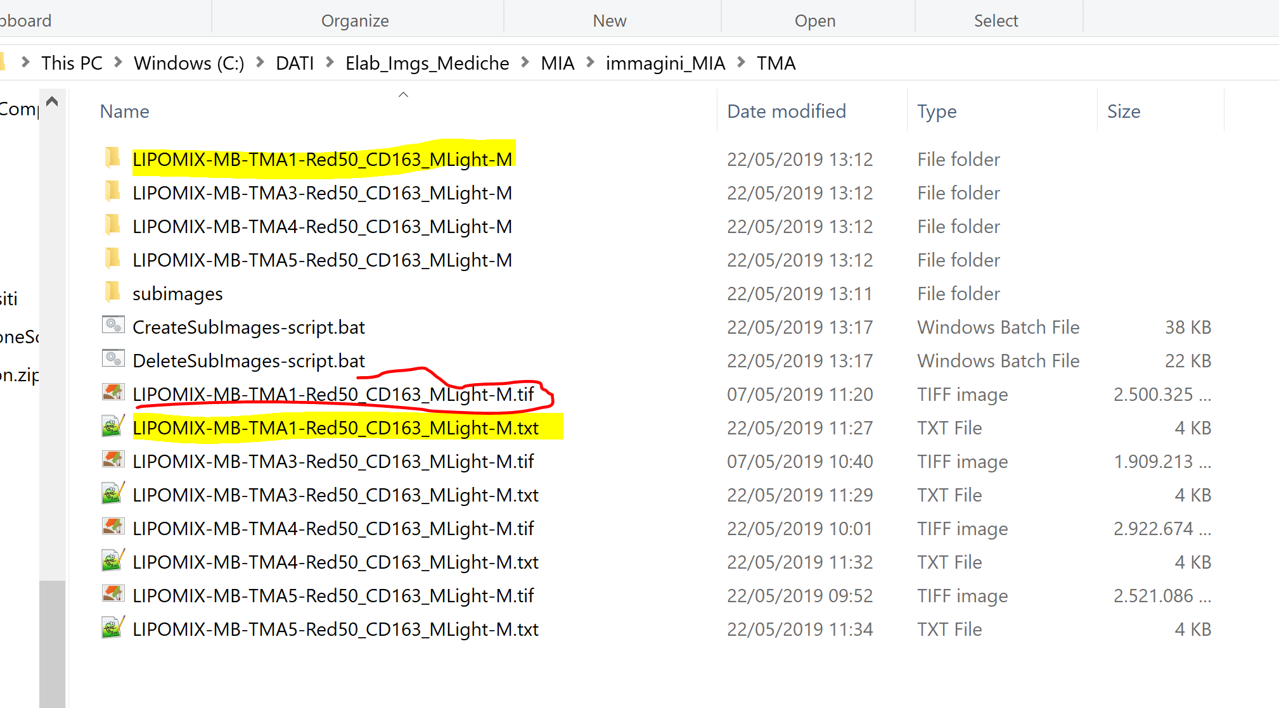

Nota che nella cartella i file *.bat e subimages ancora non ci devonoi essere.

Quelli li crei lanciando la dfunzione generaScript.m di matlab che ti genera gli script *.bat che:

1. elimina le immagini che non servono dalle dir delle sottoimmagini (DeleteSubImages-script.bat)
2. usa imageMagick per dividere la immagine in tante sottoimmagini e le salva nella cartella subimages (CreateSubImages-script.bat)

Intanto che si creano le subimages lancia la funzione EstraiRegioni.m e dai in pasto la dir con le immagini (in questo caso TMA). EstraiRegioni processa le immagini –overlay.jpg nelle sottoDir (evidenziata una in giallo come esempio) e estrae le maschere verdi rosse e gialle

Le regioni vengono salvate nella directory subimages\Masks.

Quanto tiutto è finito puoi partire con il training e la segmentazione delle sottoimmagini della cartella subimages (Ricordati che devi trovare una immagine per la color normalizzation di Rheinard. Mettila nella cartella TARGET: tutte leimgs vengono normalizzate rispetto a quella immagine (Se fai training ricordati prima di normalizzare le imgs rispetto a Rheinard!!!)

Nella img sotto ho cerchiato in rosso la cartella con la imgs TARGET per Rheinard. MIAQunat_LEarn, prima di processare ogni sottoimmagine, la normalizza di colore con Rheinard

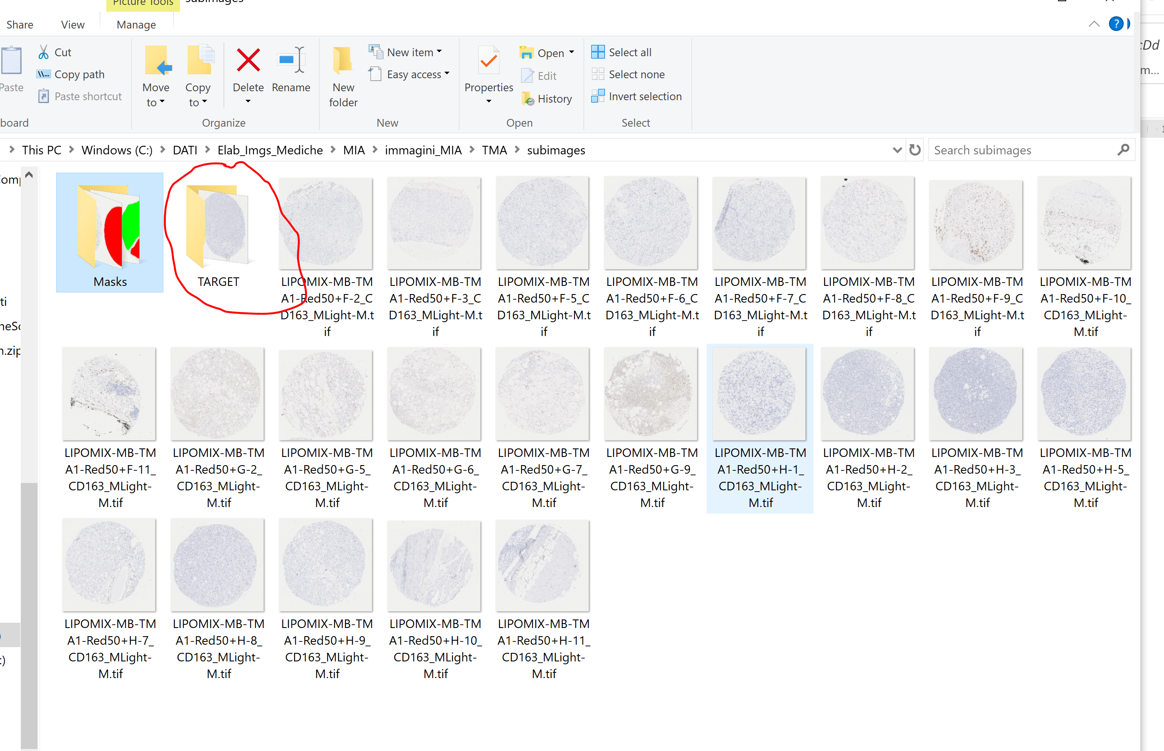

## MIAQuant_Learn Folder description

This folder contains:

* two main source files that are:
  + *“ClickSamples_TrainClassifiers.m”*: running this source file allows to collect the training data (by manually clicking on pixels in sample sub-images); after sample collection the classifiers are trained.
  + *“MIAQuant_Learn.m”*: running this source file allows to eventually register sets of serial sections, segment the markers in each section, and then compute: 1) mean-distance histograms and their intersection; 2) co-existence measures.
* the folder “\private” containing all the source files.
* the folder “\TrainedClassifiers” where the trained classifiers are saved.

**Description of processing folder and Image name protocol**

The processing folder must contain sets of (eventually serial) sections, each relative to one tissue sample.

The name of each image contains:

1) **sample code** **(reported in the first part of the image-name, delimited by “_”)**;

2) **marker name** **(reported in the second part of the image-name, delimited by “_”)**;

3) **color name** **(reported in the third part of the image-name, delimited by “_”)**:

IMPORTANT NOTE ABOUT THE COLOR NAME: the color name might be splitted into two parts separated by character “-”. The first part reports the specific color name (learnt by the analysis of sample (marker+not-marker+critical-not-marker) pixels clicked by users on sample sub-images extracted from the dataset, as explained in the paper). The second part reports the “basic color” name (learnt by the analysis of color pixels sampled by users by drawing polygons on color images). For a clearer explanation see below.

The images can be split into vertical blocks.

Precisely, if a section image is split into three blocks, the names of the three blocks are:

patCode_CD3_BMCR-R.tif,

patCode_CD3_BMCR-R.tif,

patCode_CD3_BMCR-R.tif

To end the image name description, the second part of the name, delimited by the underscore charater (“_”), reports the name of the marker (e.g. CD3, CD163, Ki67 …), while the third part reports the name of the staining color (in our examples the color is BMCR=reddish color, while the basic- color name is R). These names could be any name (e.g. pippo, pluto, brown, BMCR, …).

When only biomarker segmentation + marker co-existence estimation is needed (NO serial section registration and comparison) the processing folder must contain all the images of tissue samples (*.tif format) to be segmented. Be careful! Images must be named according to the image-name protocol described above.

## Collecting Training Data and Training the classifiers

The training data consists of:

1) pixels selected from RGB images such as:

   

The pixels selected from such images are used as training pixels for a decision tree (DT) which discards pixels whose color is completely different from that of marker pixels. If the basic color is named “nameBasic”, the user-selected training pixels are saved in folder “\TrainedClassifier\DataBasicColor_nameBasic”.

2) marker-pixels, not-marker pixels, critical-not-marker pixels manually clicked from the images to be processed. IMPORTANT: since the images are usually characterized by an high pixel dimension, directly selecting training pixels from them is be too time consuming (Matlab takes more time to open images of high dimensions). For this reason, we recommend to select training pixels from image portions (sub-images) extracted from the images to be processed and saved in a separate folder. The sub-images portion must be named according to the name protocol and we suggest they are extracted in order to capture all the different marker color appearances, and all the deficits that must be faced. Selecting pixels from these sub-images allows to have a training set containing all the positive and negative examples that must be faced by the classifiers. In the following we will referred to the sub-image folder as sampleImage folder. If the color is named “nameColor”, the user-selected training pixels are saved in folder “\sampleImages\DataColor_nameColor”. Saving the training points is important to eventually update them by adding extra points.

To select training points, open “ClickSamples_TrainClassifiers.m” (saved in the MIAQuant_Learn folder) with the latest Matlab release (see image below).

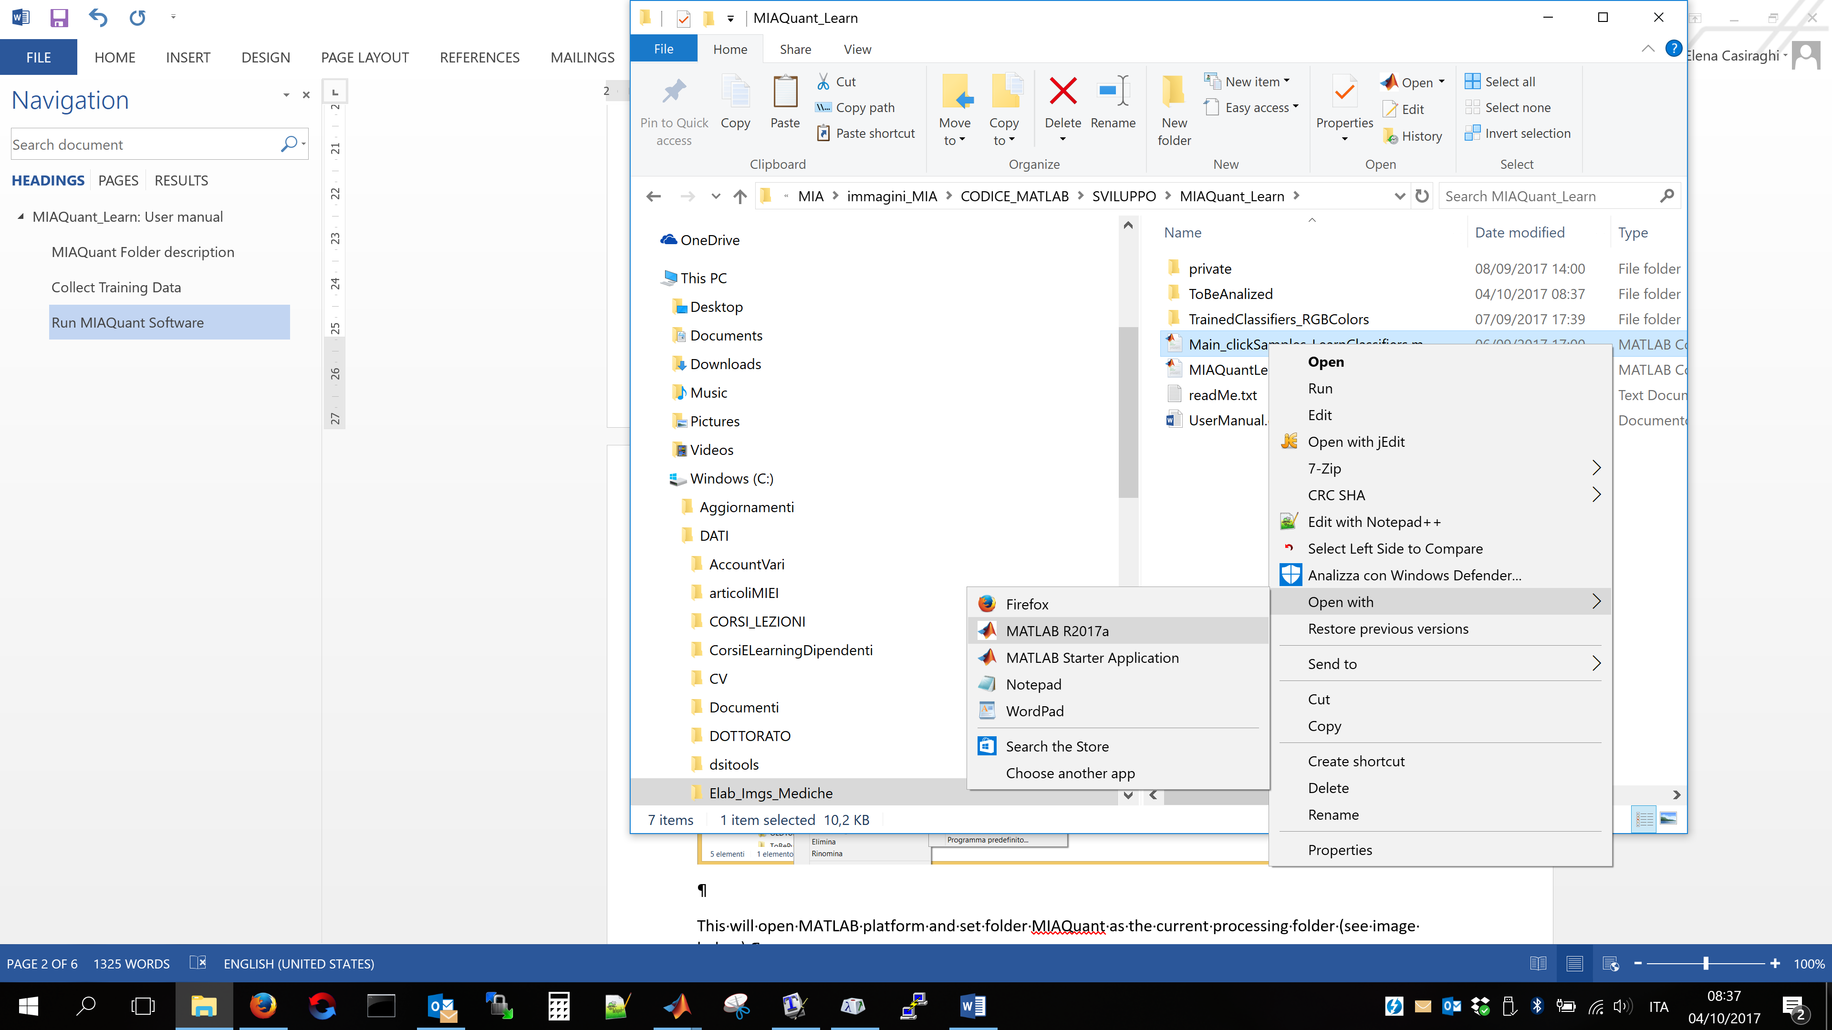

This will open MATLAB platform and set folder MIAQuant_Learn as the current processing folder (see image below).

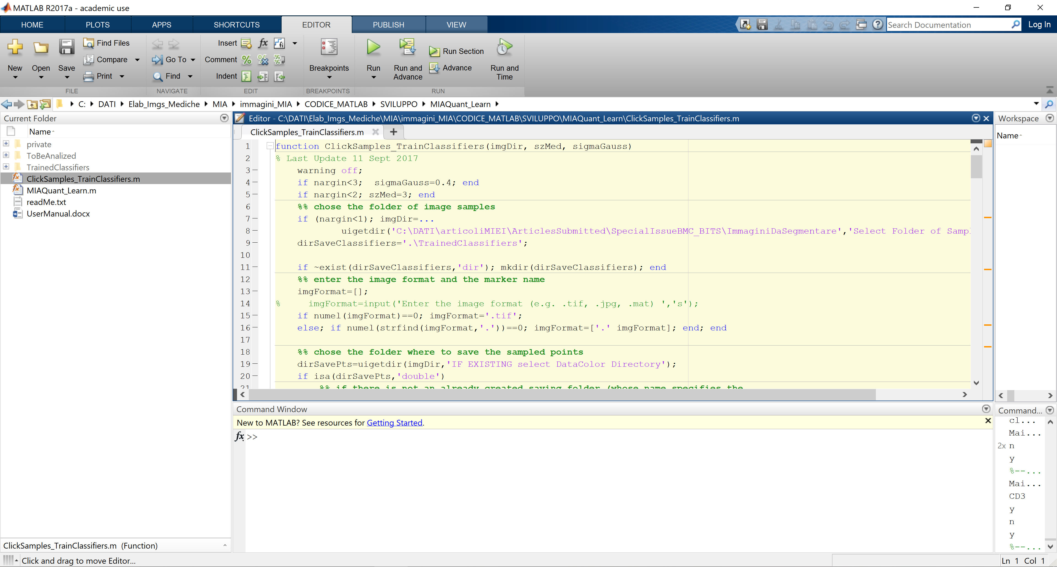

To run the code, in the command window write “ClickSamples_TrainClassifiers” and press ENTER (see image below)

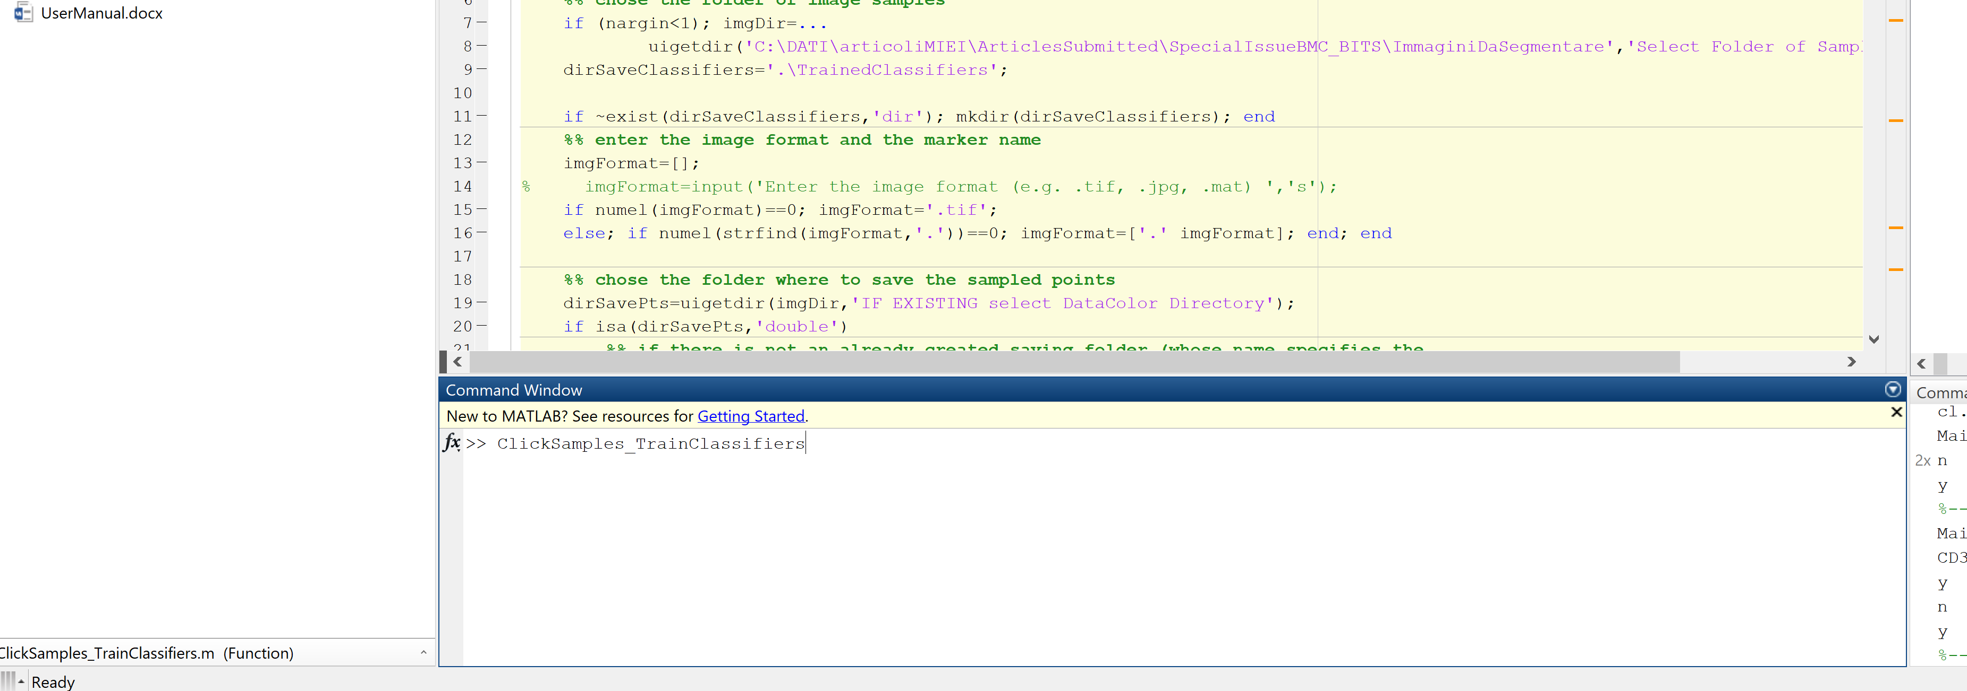

When the function starts, it opens a dialog box and asks you to locate and select the sampleImages folder in your PC (see below)

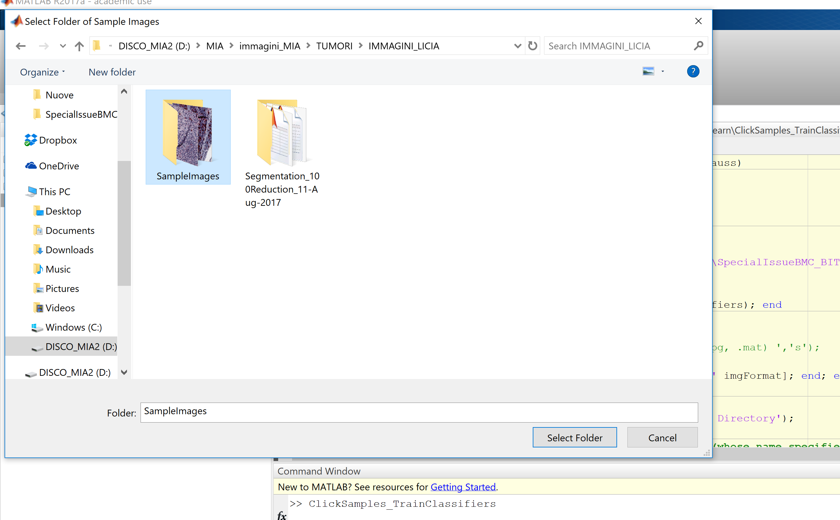

After this step MIAQuant_Learn parses the name of the first image in the folder and understand the name of the color that must be learnt (this is done by analyzing the color name written in the image name).

As an example, if the name of the first sub-image found in the folder is:

sample1_CD3_**BMCRV-R**.tif

MIAQuant_Learn understand that the user wants to use a basic color classifier named R and a stacked classifier recognizing a color named BMCR. In the following we will refer to the basic color name as baseColor, and to the specific color name as markerColor.

At first, MIAQuant_Learn checks whether a basic color classifier named basicColor already exists in folder TrainedClassifiers (as an example, if basicColor = R – which supposedly stands for red color – the basic color classifier might be existing if the user has already segmented markers with a reddish appearance; in this case he has created and used a basic color classifier named R to firstly screen all the red colors. Basic color classifiers can be recycled to segment any marker with reddish appearance). In this case, it asks if the user wants to train a novel basic color classifier. If the user prompts Y, a novel basic color classifier is trained. This happens also is the basic color classifier is not existing yet.

To select training pixel for the basic color classifier, the user is shown the RGB images and is asked to draw polygons including pixels whose color is that of the markers’ basic color (see below).

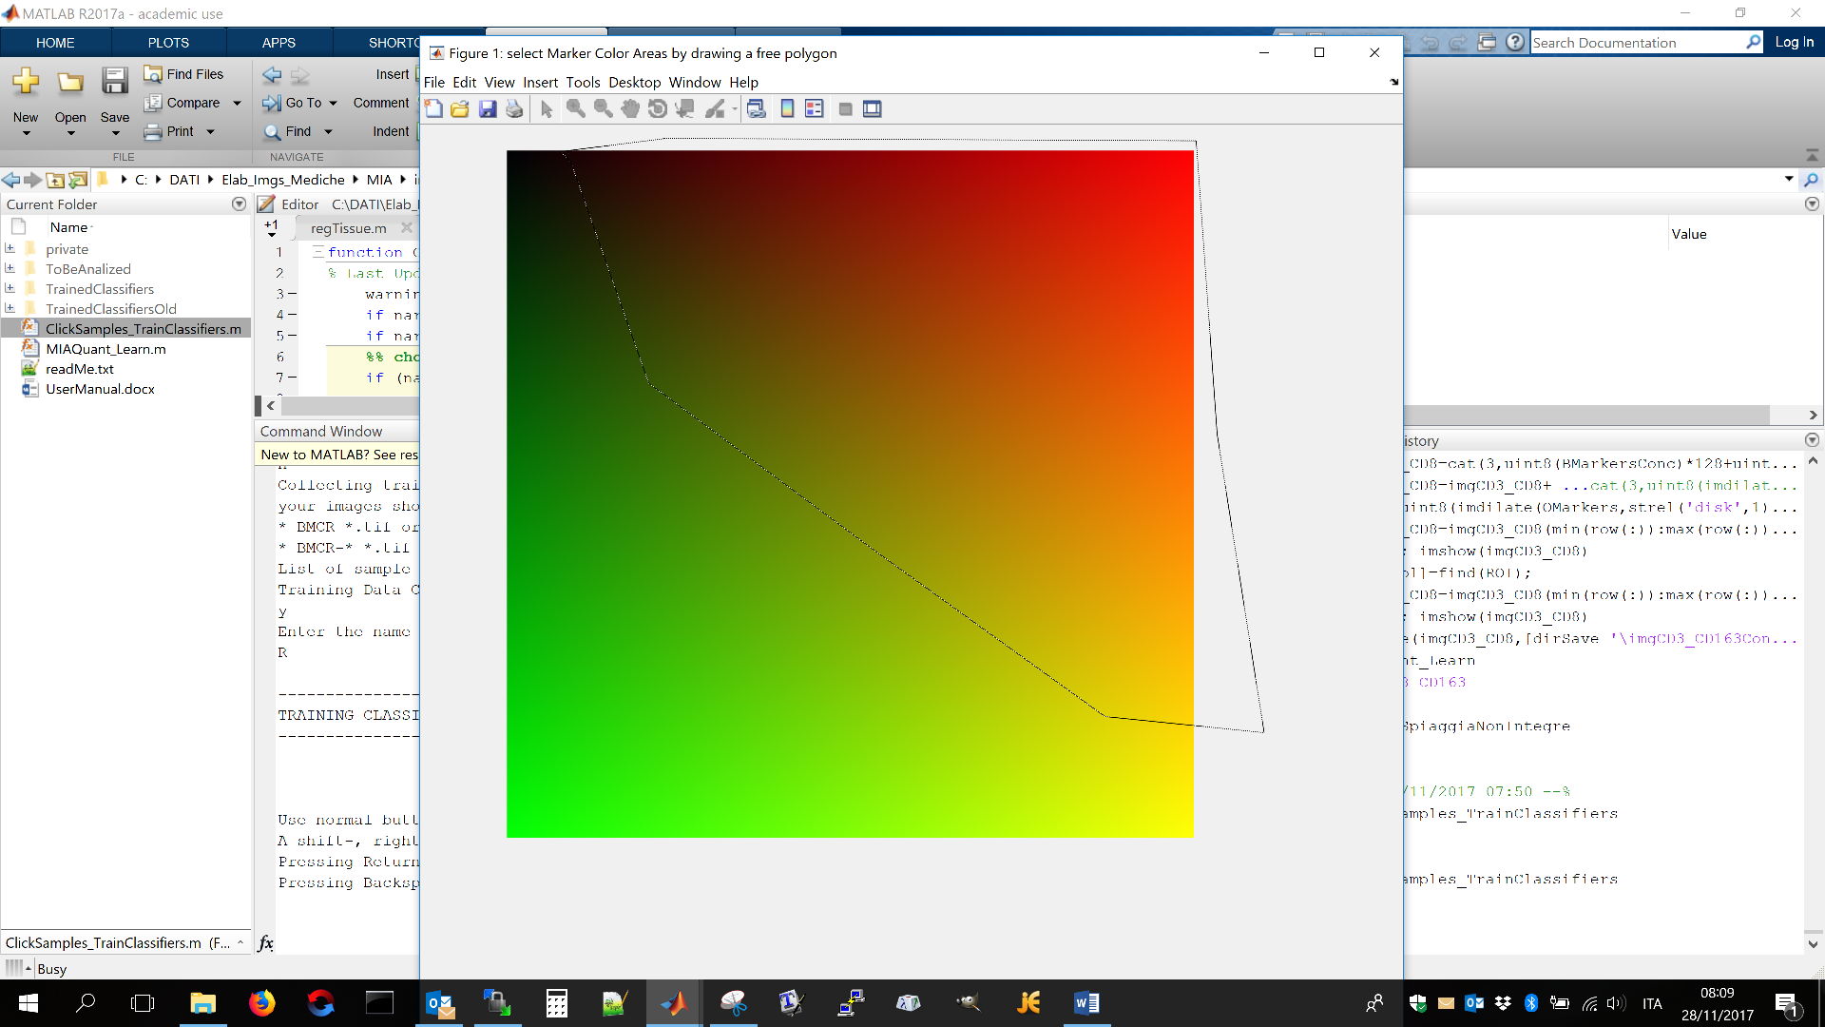

To end insertion of the closed line the user must double-click.

After selecting polygons on all the images (note that is an image does not contain pixels with the basic color to be learnt, the user can press enter to select no pixels), the basic color classifier is trained and saved in folder TrainedClassifiers.

After this step, the function checks if sampleImages contains a folder name “DataColor_markerColor” directory. This directory is created at the first run of the function “ClickSamples_TrainClassifier” and contains the points already clicked on the sample sub-images. At the first start, the directory is not existent and it is automatically created.

If folder “DataColor_markerColor” is already existing, MIAQuant_Learn output a message notifying that the directory already exists, meaning that the training points will be updated (see below)

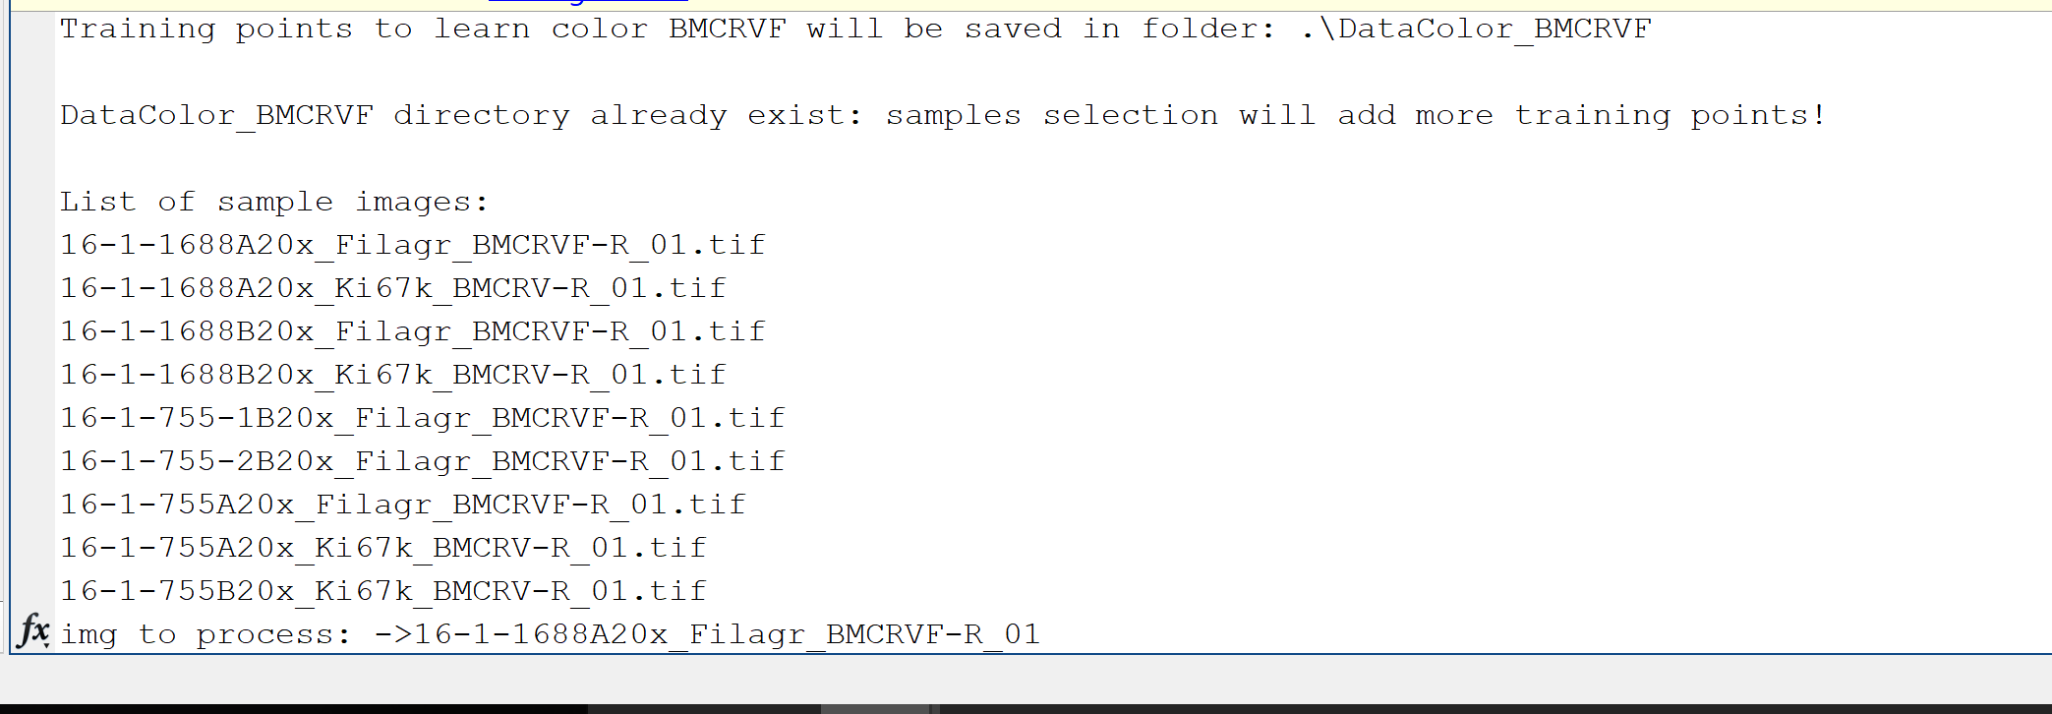

After this message, the list of sample images found in folder SampleImages is listed, and the function starts showing the name of the image to be clicked, and asking whether the user wants to click on it or skip it (see below)

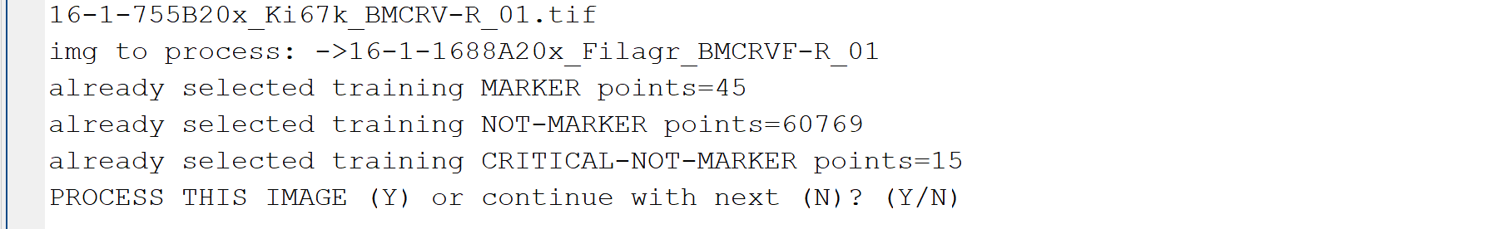

Inserting “N” will skip the image and ask about the next.

Inserting “Y” will open and show the image, asking to click on “center of areas where to select marker-pixels” (see below)

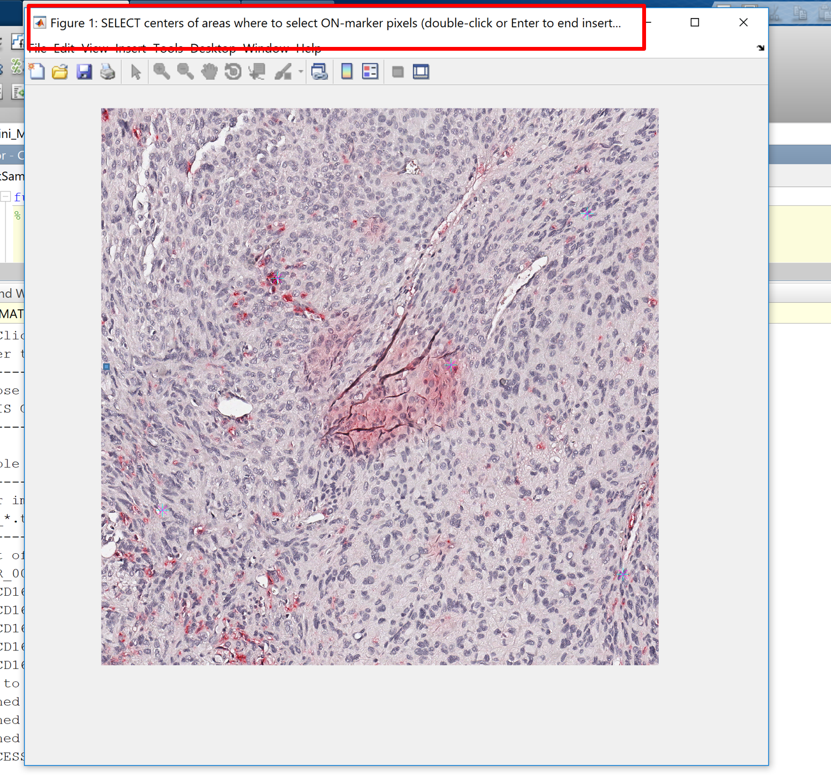

For each click, a sub-image containing the detail will be shown, and the user will be asked to select marker-pixels (see below). To end clicking on marker-pixels the user must press the “Enter” button on the keyboard.

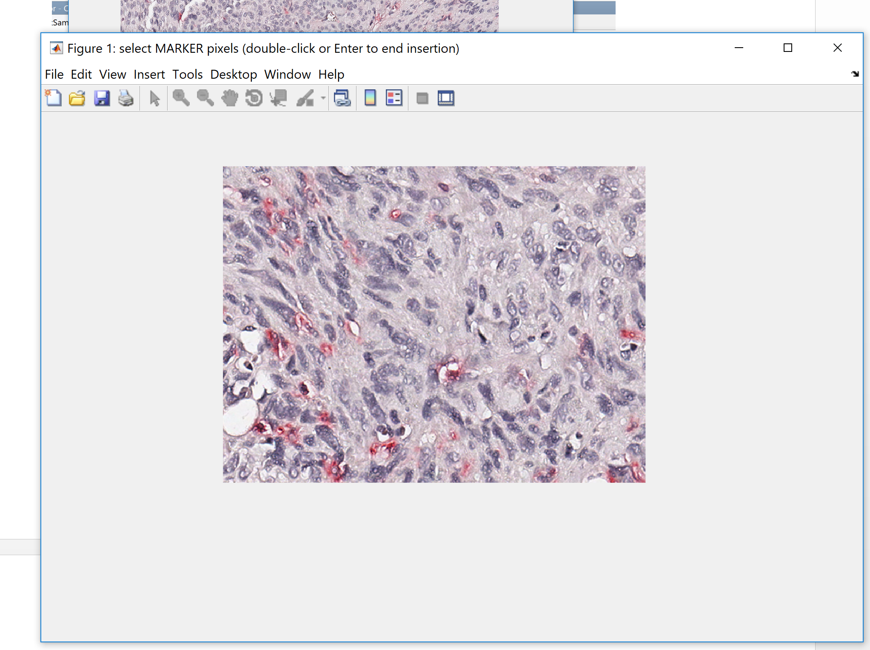

After selecting the marker pixels, a similar procedure is applied for selecting the not-marker points.

When clicking the not-marker pixels the user will note two differences:

* on each small image portion the user must firstly select the “obvious” not-marker pixels by drawing rectangular areas (if the user wants to click on not-markers he just needs to click one and the rectangular selection modality will switch to clicking selection modality);
* after finishing to click on not-marker pixles by pressing the “Enter” button the image portion is shown again and the user is asked to click on the critical not-marker pixels (pixels whose appearance is similar to marker-pixels, or pixels in folds, etc…)

When the user has finished clicking on each image, he can decide to proceed clicking on a novel sample image, or he might end clicking, to either train the classifiers with the collected training points, or interrupt clicking to start again later.

If the user presses Y continue clicking on the next image. Otherwise, he ends insertion. In this case, MIAQuant_Learn collects the training data (that is it codes the training points as 24 dimensional vectors).

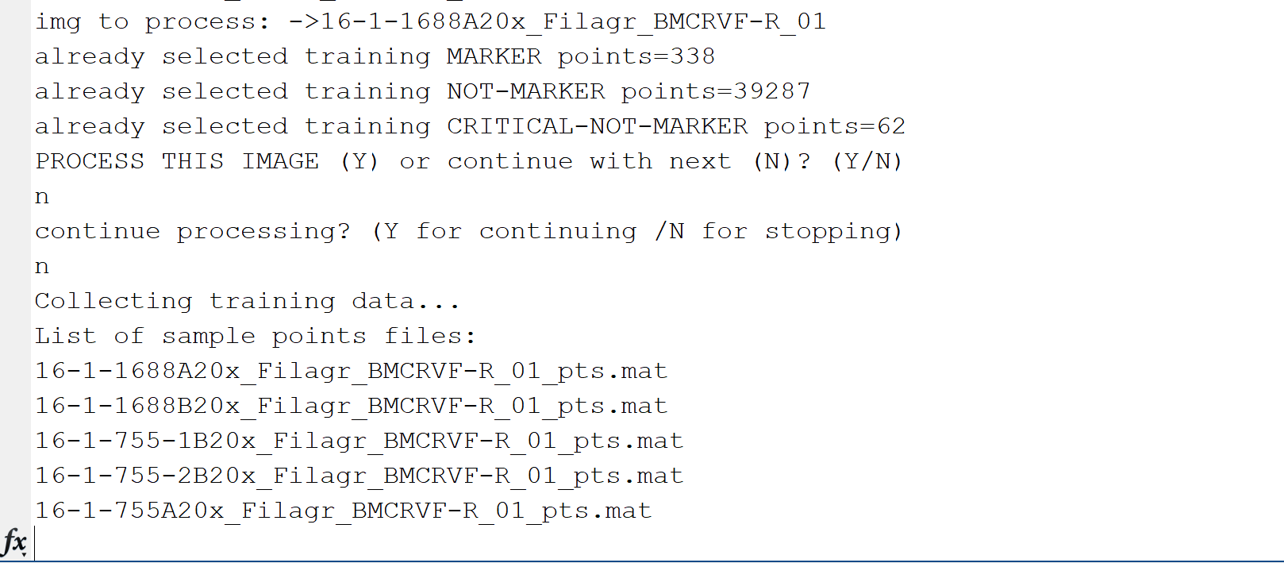

After this step it classifies training data with the basic color classifier, and outputs the achieved performance (see below).

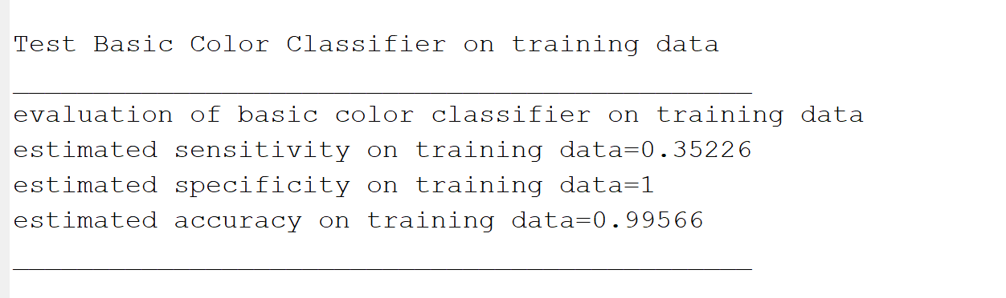

Note that this output allows the user to decide whether the basic color classifier must be retrained (as in this case!!) Indeed, the sensitivity is too low and would discard almost all the marker pixels. We recommend retraining the basic color classifier if sensitivity is lower than 0.99. Specificity is less important in this case (specificity values greater than 0.5 can be accepted, though they are generally much higher).

NOTE: If the user wants to retrain the basic color classifier he can finish the ongoing training and then restart the procedure. After training the basic color classifier he just stops to insert training points as soon as training point selection starts.

After classification with basic color classifier, the user is asked if the classifiers for marker color selection must be trained:

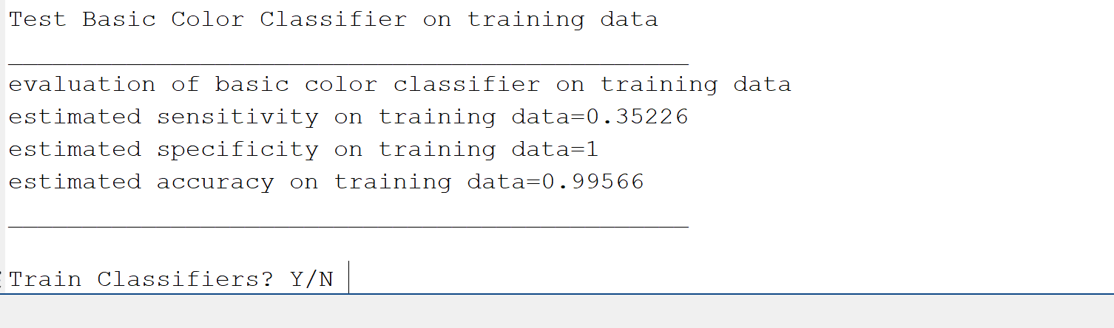

If the user answers “Y” training starts, otherwise the program is stopped (the user is expected to click later on some other images and then train the classifiers).

When the user wants to restart collecting training samples, he must launch again the function “ClickSamples_TrainClassifiers”, select the “SampleImages” folder, and then SELECT “DataColor_R”(if the color name chosen was “R”) WHEN THE SOFTWARE SHOWS A DIALOG BOX ASKING: 'IF EXISTING select DataColor Directory'.

IMPORTANT NOTE:

The user might not need to train the basic color classifier (though we suggest to do it). If no basic color classifier is trained, the image names will have the following format:

patCode_CD3_BMCR.tif,

patCode_CD3_BMCR.tif,

patCode_CD3_BMCR _03.tif

that is, the name of the color contains only the trained color name. We mark that the basic color classifier allow to discard most negative marker pixels and speed up computation. Moreover, basic color classifiers might be used whenever novel markers with the same basic color appearance must be segmented (as an example, we used a basic color classifier trained to recognize brown markers for completely different brownish markers appearances). After recognizing the basic color, the discrimination among the more specific color appearance is left to the stacked classifier machine, trained by the user clicks on the smple images.